Email Security Scanner
Design Document
Dev. Team: Chris Deck | Tom Miller | Chris Porch | Steve Leonetti
Product Owner: Dan Smith
Scrum Master: Michael Bayruns
Document Written By: Chris Deck, Michael Bayruns

Table of Contents
1Purpose 3
2Scope 3
2.1Exclusions, Assumptions, and Limitations 3
3Solution Design Overview 3
4Technical Implementation 5
4.1 Software Requirements 5
4.2 Middleware Hosting 5
5Security Design 6
6Solution Design 6
7Roles and Responsibilities 10
8Terms and Definitions 10
9Revision History 11
Appendix A 12

Purpose
This document presents the Solution Development Lifecycle (SDLC) Design / Installation Information for a Project affecting the ASRC Email Scanner.

Scope
The scope of this document includes the code that the development team has written, and the structure of the project as it is today. Some Architecture in the large diagrams may change as the product progresses.

Exclusions, Assumptions, and Limitations
This Document does not cover any code written by third-parties. These libraries are assumed to be documented by their own developers and the team is just using their services. These libraries include java libraries, Apache Lucene, WordNet, etc. These libraries will be explained to show how they work, and how they are being implemented.

Solution Design Overview
The Security Email Scanner has one main goal: to determine if an E-Mail is confidential, and if so, confirm that the user wishes to send confidential information. It is not a mechanism to block e-mails from getting out, more of a measure to assume responsibility. Below is a logical view of the system.
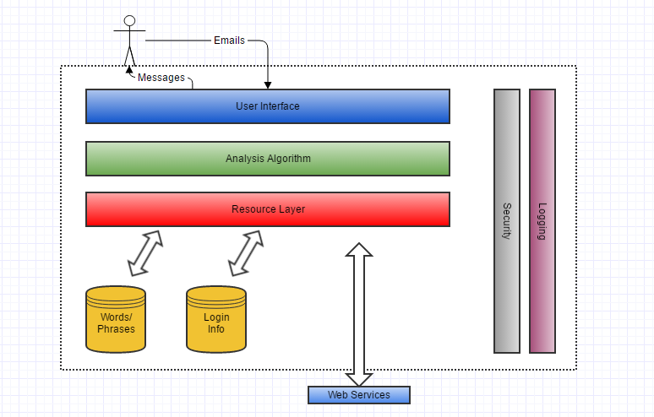
Figure 3.1 - Logical View of the System

Technical Implementation
The current implementation of our program features four main GUIs. The Login GUI requires you input a username and password to access all features of the program. The password entered is hashed and compared to the ones stored in the database using B-crypt. The scanner GUI takes input of words or phrases and returns a score based on the level of confidential material entered into it. This is accomplished through parsing the input, hashing each word, and then comparing the hashed values with the ones in the database. The Database GUI can be used to add additional terms to the database. Finally the training GUI can be used to train the program. It does this by modifying the values of each confidential word stored in the database based on the result - confidential or clean. This training GUI can be used to load in several sample emails and score them individually to modify the values stored in the database.

4.1 Software Requirements
All dependencies should be pulled by Maven when you first run anything. Code requires Java 1.8. If you package the project in the command line using the mvn package command, it should generate a sweng-eagles-1.0.jar file in the target directory that should open the login window. As of right now, that is how the program is run. The eventual design is to implement it server-side, or as a Microsoft Plug-in as previously stated.

4.2 Middleware Hosting
A SQL database is needed for this application. The database settings should be configured in the Graphical User Interface of the application. The databases tables and relationships are defined in the figure below.
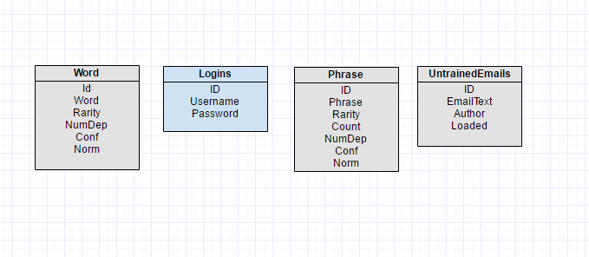
Figure 4.2.1 - Entity Relationship Diagram

Security Design
The program uses SHA-512 & B-Crypt hashing algorithms to one-way hash passwords, and confidential words & phrases. There is currently a Hashing-Whitepaper up on our GitHub page for more information. The link to the GitHub is in the Appendix. The system also encrypts emails and sends them to the database to be used later for training the algorithm. These emails are encrypted using AES and the key for this encryption is encrypted in RSA for further security.

Solution Design
The following diagrams show what our system does, and how it works. There will be a small explanation with each diagram for further explanation.

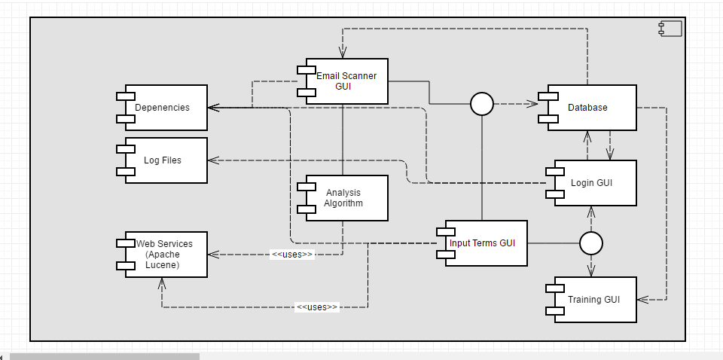
Figure 6.1 - Component Diagram
Apache Lucene is a web service the program uses to stem words and phrases down to the root word(s). It takes away unnecessary words like "the" & "a" and can be configured to take off plurals, which we have included in our program. Below is an object diagram to show an example of how it stems.
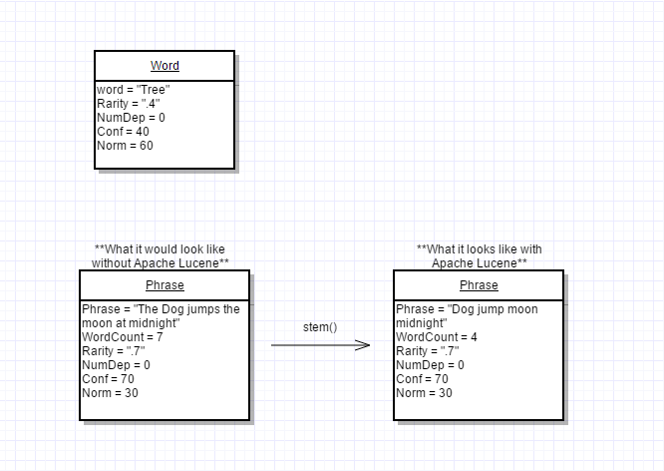
Figure 6.2 - Object Diagram
This diagram accurately represents how the words and phrases are stored and what values they have.

More information on the project can be found on our GitHub repository, including the ReadMe document, the code, and the Hashing Whitepaper. As previously stated, the link to the repository is in the Appendix.

Roles and Responsibilities
The IT Solution Delivery Lifecycle Procedure, describes the Roles and Responsibilities for developing, verifying, and implementing a Solution. There are no additional roles specific to this document.

Terms and Definitions
The IT Glossary of Terms maintains the common terms in this document. There are no additional terms and definitions to this document.

Revision History
Update this table each time this document is revised. Where possible, include a Change Number or Project related to the document change. Entries should provide the reader with only an indication of what changed. Include section where a change took place. Add rows as necessary.
Version | Version Date | Revisions
1.0 | 11/20/16 | Initial Revision
1.1 | 12/15/16 | Final Sprint Revision – changed document to correctly reflect the program
1.2 | 12/19/16 | Final Revision - final change based on the outcome of the final sprint meeting

Appendix A
GitHub Repo - https://github.com/cbporch/sweng-eagles
Development View - https://www.gliffy.com/go/share/s3a3e8w1fyasifvh4ifq
`

